Q1

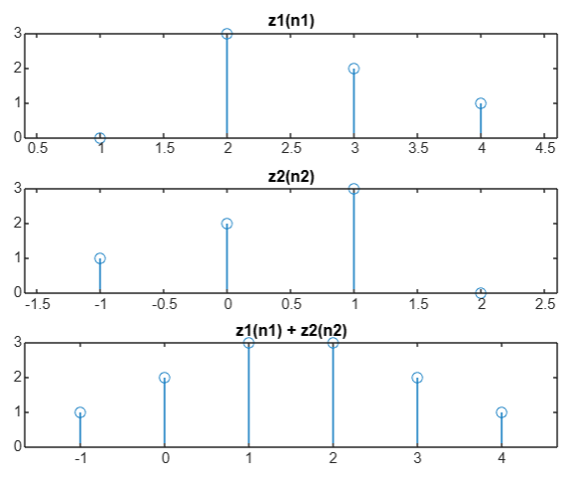
z1 = [0, 3, 2, 1];
n1 = [1, 2, 3, 4];
z2 = [1, 2, 3, 0];
n2 = [-1, 0, 1, 2];
[y, n] = sigadd(z1, n1, z2, n2);

subplot(3, 1, 1)
stem(n1, z1)
title('z1(n1)');

subplot(3, 1, 2)
stem(n2, z2)
title('z2(n2)');

subplot(3, 1, 3);
stem(n, y);
title('z1(n1) + z2(n2)');

function [y, n] = sigadd(x1, n1, x2, n2)
n = min(min(n1), min(n2)):max(max(n1), max(n2));

y1 = zeros(1, length(n));
y2 = zeros(1, length(n));

idx1 = (n >= min(n1)) & (n <= max(n1));
idx2 = (n >= min(n2)) & (n <= max(n2));

y1(idx1) = x1;
y2(idx2) = x2;

y = y1 + y2;
end
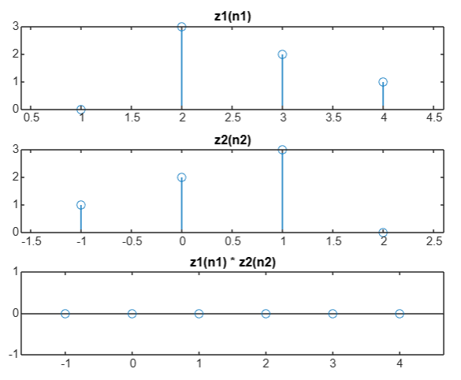

Q2

Q3

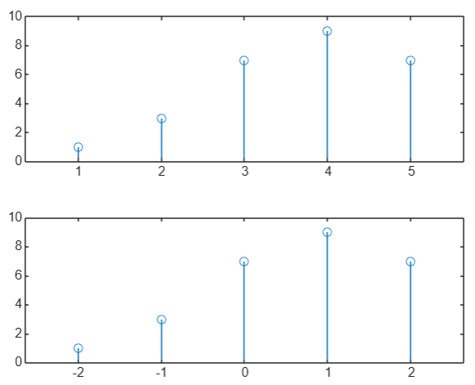
x=[1,3,7,9,7];
n=[1:1:5];
subplot(211)
stem(n,x)
subplot(212)
stem(n-3,x)

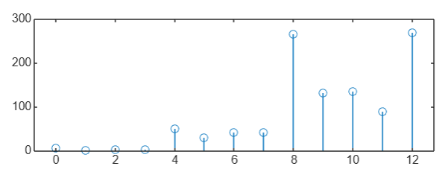
Q4 Q5
x=[1,2,5,8,3,2];
n=0:length(x)-1;
subplot(211)
stem(n,x)
x=fliplr(x)
subplot(212)
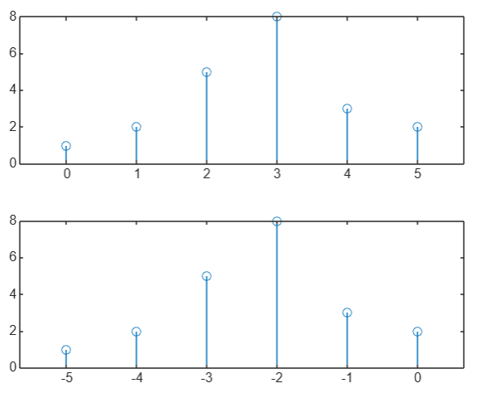
stem(-n,x)

a=[1,2,3,4,5,6,7,6,5,4,3,2,1];
n=0:length(a)-1;
a(1)=7;

for i=5:length(a)
a(i)=3*a(i)+a(i-4)*a(i);
end

stem(n,a)

Q6

x = [0, 7, 5, 4, 8, 2, 6, 3, 8, 9, 10];
sum_x = sum (x) ;
disp ( ['Sum of the samples of x (n) : ', num2str (sum_x) ]) ;

